**Lesson 11 Demo 2**

**Manage VM Sizes**



Steps to be followed:

1. Managing VM size

**Step 1: Managing VM Size**

1.1 Log in to the Azure portal at <https://portal.azure.com>

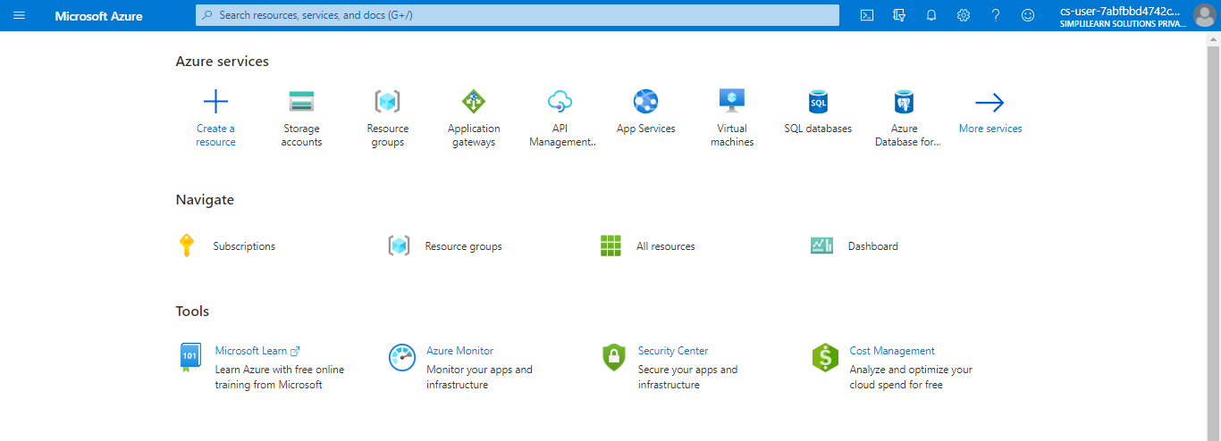

1.2 Search for **virtual machines** in the Azure portal

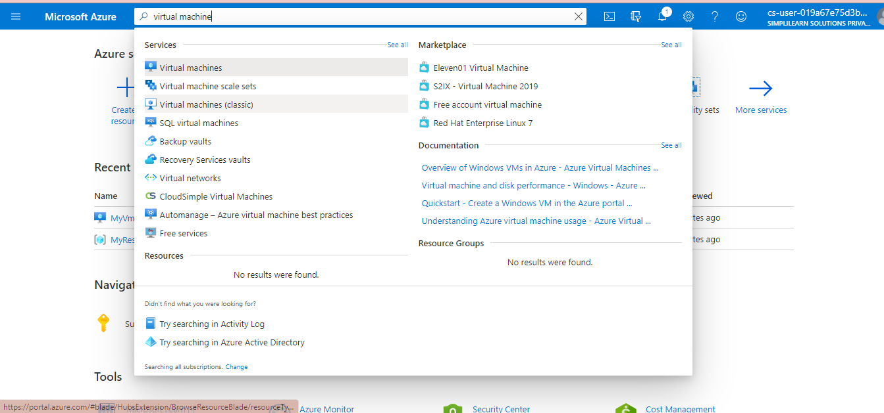

1.3 Under **Services**, select **Virtual machines**

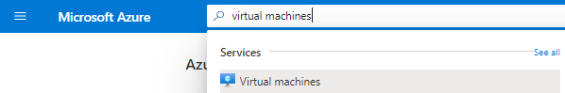

1.4 Click on the Azure VM that you want to resize

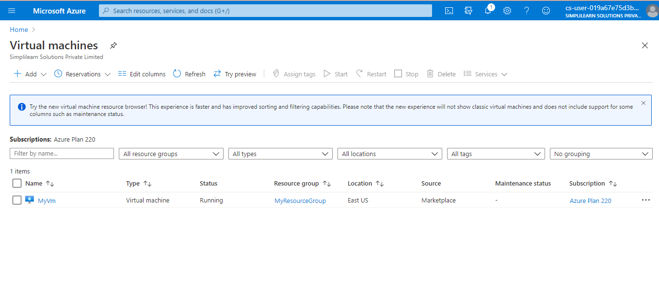

1.5 In the left menu, select **Size** under **Settings**

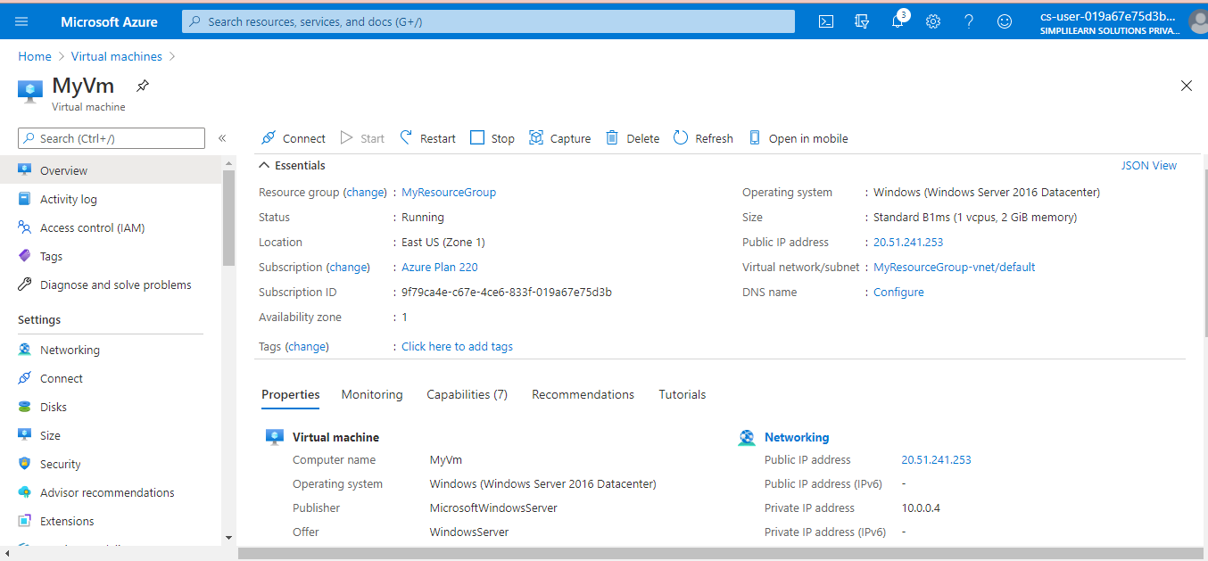

1.6 Pick a new size from the list of available sizes and then select **Resize**

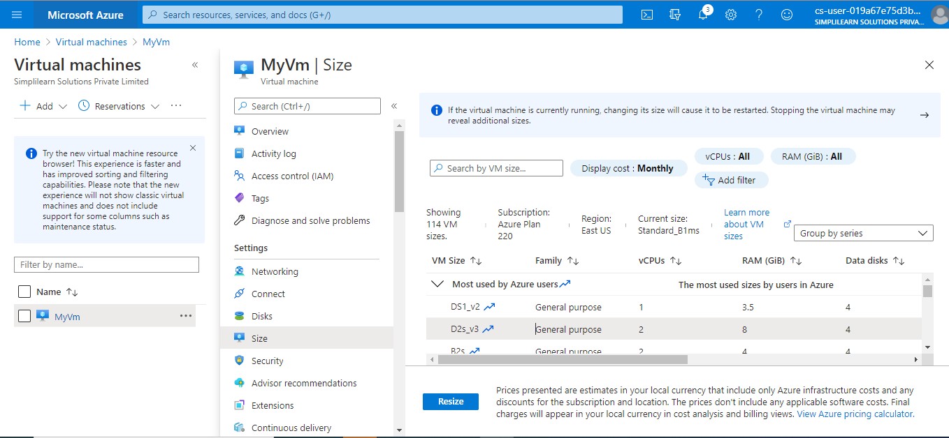

Wait for a few seconds, your VM will be resized.

